|  |  |
| --- | --- |
| Semester | T.E. Semester VI – Computer Engineering |
| Subject | Cloud Computing |
| Subject Professor In-charge | Prof. Divya Nimbalkar |
| Assisting Teachers | Prof. Divya Nimbalkar |

|  |  |
| --- | --- |
| Student Name | Deep Salunkhe |
| Roll Number | 21102A0014 |
| TE Division | A |

**Title:**

Implementation of IaaS



**Implementation:**

**Scenario 1**

1. **Create a Ubuntu VM ( Any Ubuntu Machine) and connect using SSH**
2. **Install an ngnix web server on this machine**
3. **Display the default web page of ngnix server on public IP address of the machine**
4. **Change the default page content with your content to perform static website hosting**

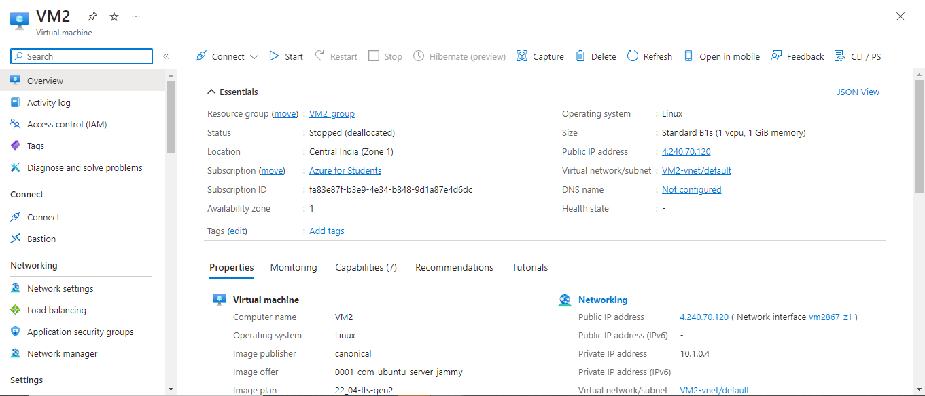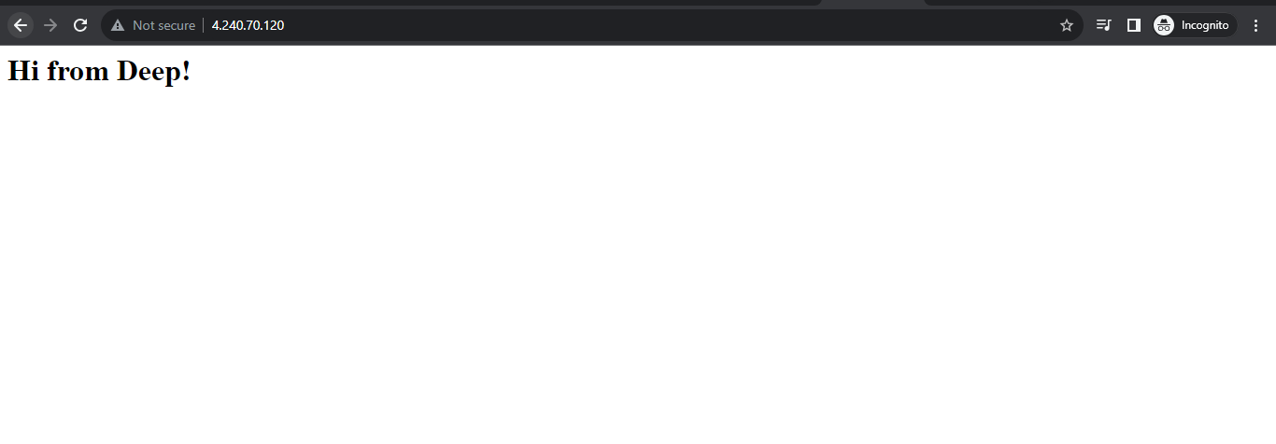

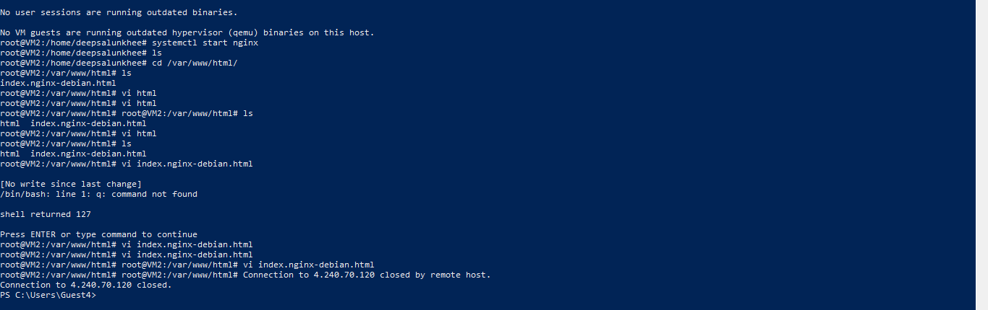

Scenario 2

1. Create a Windows VM ( Any Windows Server Machine) and connect using RDP
2. Install an IIS web server on this machine
3. Display the default web page of IIS server on public IP address of the machine
4. Change the default page content with your content to perform static website hosting

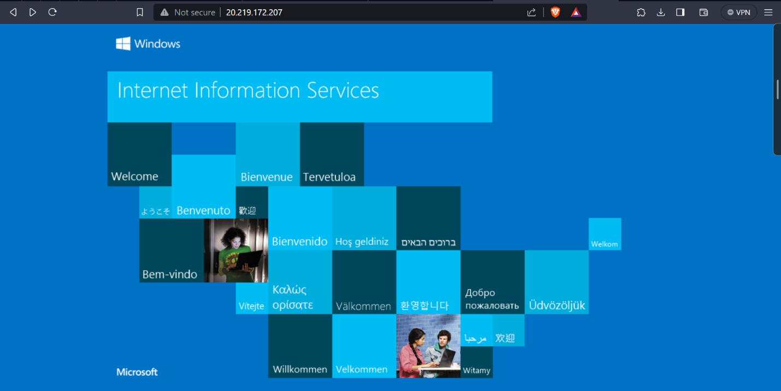

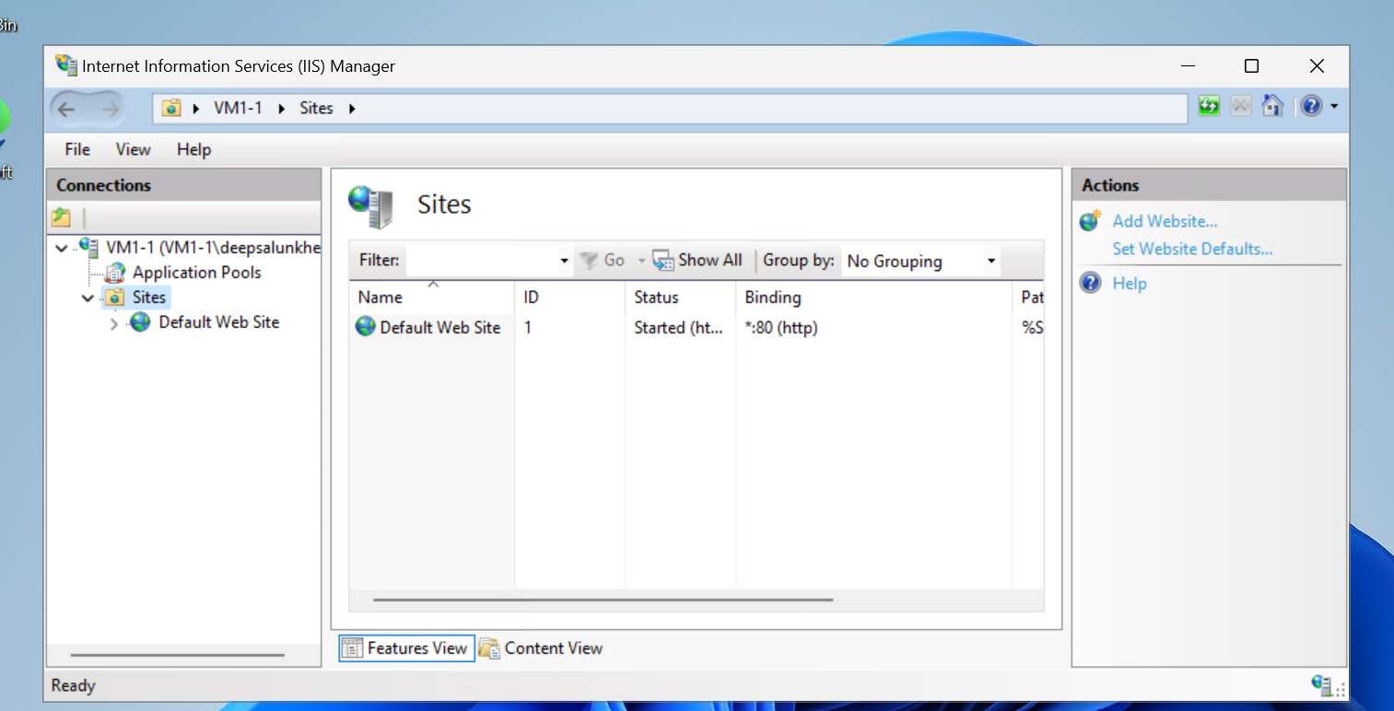

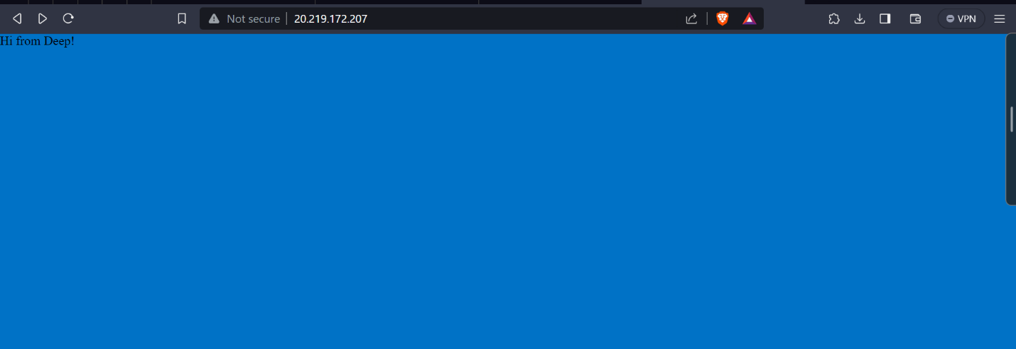



**End Result:**



**Conclusion:**